

Best Practices

Concierge Maintenance

Deleting Old Profiles

If you are a property that uses the MARSHA Import aspect of The Concierge Assistant, proper maintenance on deleting Profiled Guests is necessary to keep The Concierge Assistant in top running order.

All old or “Departed Profiles” should be deleted regularly, just fill in the date you want the Profiles deleted to (the date will always assume the current day of the current month). After you have selected the date, just push the button to “Delete Guest Profiles”.

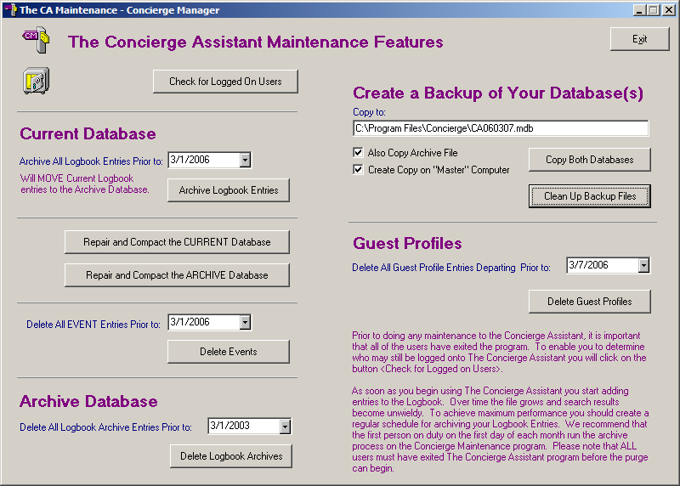

Always remember to Repair and Compact the CURRENT and ARCHIVE databases after performing maintenance like this.

It would also be wise to make a copy of the database after doing this on the designated “Master” computer.

